|  |  |  |
| --- | --- | --- |
| **利率下降、资产荒与股票投资**  **股票市场运行周报**  **宏观经济与债券市场 旗下基金表现** |  |  |



**利率下降、资产荒与股票投资**

10月中旬最新月度通胀数据显示，经济通缩继续；从国内利率中期走势来看，和中期经济潜在增速密切相关。随着中国经济增长速度放缓，利率总体是在不断下行。不管愿意与否，五十万亿的居民储蓄存款在不断走低的存款利率趋势下面临资产重新配置选择。

相对而言，股市和股票型投资基金可能是较好的资金配置选择，尤其是具有良好成长前景产业中的优质公司股票，毕竟我国经济发展到今天，产业升级和经济转型是唯一出路。新兴产业由于其良好的发展空间，其享受较高估值一定会伴随整个转型期。而在利率下降大周期内，具有核心竞争力的传统行业价值型公司也不会寂寞，其龙头地位更加稳固，股票市场风格轮动也会以成长股主导，价值股跟随补涨的方式交替演绎。

**股票市场运行周报（20151102-20151106）**

**交银施罗德量化投资部**

本周上证综指上涨6.13%，深证成指上涨6.30%，中小板指数上涨5.25%，沪深两市成交量为49,053.66亿元。非银金融、休闲服务、建筑装饰涨幅最大，分别上涨17.45%、10.90%、9.51%。从行业换手率来看，计算机行业换手率最大，换手率为24.90%。

**利率下降、资产荒与股票投资**

**交银新成长基金经理 王崇**

10月中旬最新月度通胀数据显示，经济通缩继续，CPI环比上涨0.1%，同比上涨1.6%；而PPI环比下降0.4%，同比下降5.9%，连续44个月为负（见下图一）。一周后人民银行宣布双降，自10月24日起调降一年期人民币存款与贷款基准利率0.25个百分点。同时自24日起下调存款准备金率0.5个百分点。

从国内利率中期走势来看，和中期经济潜在增速密切相关，尽管期间有几年会有通货膨胀经济过热加息导致利率上升的干扰。随着中国经济增长速度放缓，利率总体是不断下行（见下图二）。尽管一年期信托收益率由于多种因素仍旧下行不明显，但一年期全市场理财利率已经出现明显下降（见下图三）。与利率水平不断下行伴随的是债券市场的不断走牛，中证全债指数2008年中期以后总体持续震荡上行。股票市场虽然波动较大，但以年度计量，除了2011年因阶段性通胀宏观调控导致跌幅较大以外，其他年份均有较好的投资机会，也就是说在利率趋势性下降过程中，股票市场总体提供较好的回报。

从近期国内经济增长状况而言，房地产和基建投资大幅增长的动力趋缓，而新的经济增长动力尚未出现，经济增速仍旧在寻底过程中，经济增速放缓、PPI为负通缩延续、利率不断下降可能是未来很长一段时间的经济主基调。这一次降息后，不考虑利率上浮，一年期定期存款利率低于CPI大约0.1个百分点。

不管愿意与否，五十万亿的居民储蓄存款在不断走低的存款利率趋势下面临资产重新配置选择。理财产品和债券是个不错替代品，但其收益率的持续走低导致吸引力逐渐下降，尤其是信用风险溢价已经较低的情况下。房地产市场过去十几年来一直是居民资产配置的重要方向，但目前三、四线城市巨大的商品房库存以及全国人口结构和人口迁移特征决定了除了一线城市以外，大部分地区房价已经涨不动了，房地产投资对三四线城市居民已经逐渐失去吸引力。对大型机构大资金而言，也同样面临市场缺乏提供较高收益率和较好流动性的资产来配置的问题，甚至出现所谓的资产荒。相对而言，股市和股票型投资基金可能是较好的资金配置选择，尤其是具有良好成长前景产业中的优质公司股票，毕竟我国经济发展到今天，产业升级和经济转型是唯一出路。新兴产业由于其良好的发展空间，其享受较高估值一定会伴随整个转型期。而在利率下降大周期内，具有核心竞争力的传统行业价值型公司也不会寂寞，其龙头地位更加稳固，股票市场风格轮动也会以成长股主导、价值股跟随补涨的方式交替演绎。

图一：

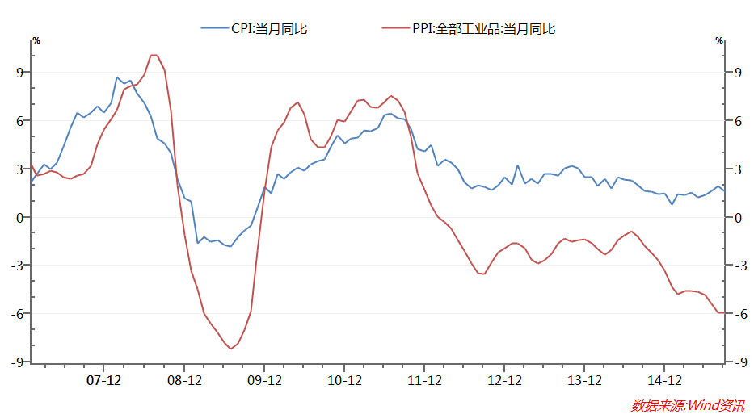

图二：

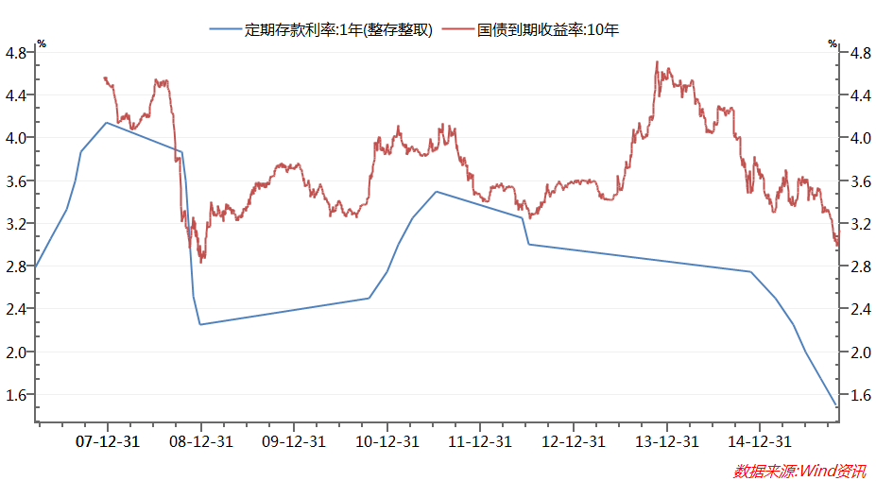

图三：

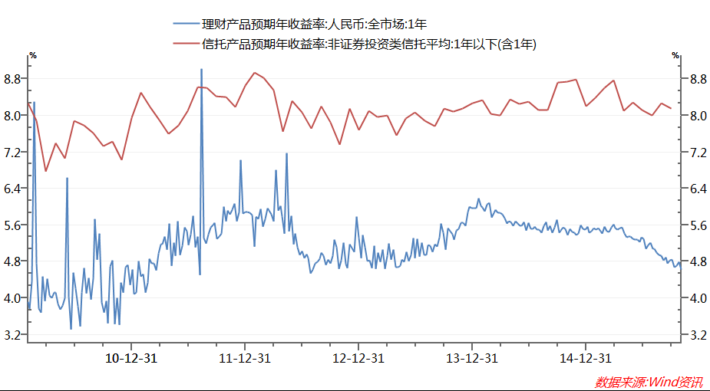

**股票市场运行周报（20151102-20151106）**

**交银施罗德量化投资部**  
本周上证综指上涨6.13%，深证成指上涨6.30%，中小板指数上涨5.25%，沪深两市成交量为49,053.66亿元。非银金融、休闲服务、建筑装饰涨幅最大，分别上涨17.45%、10.90%、9.51%。从行业换手率来看，计算机行业换手率最大，换手率为24.90%。

**表1:指数表现**   **表2:市场总体指标**

|  |  |  |  |  |  |
| --- | --- | --- | --- | --- | --- |
| **指数名称** | **区间**  **收益率** | **成交金额**  **（亿元）** |  | **市场总体指标** | **数值** |
| 上证综指 | 6.13% | 21,784.4 | A股总市值（亿元） | 561,452.44 |
| 上证180 | 7.13% | 9,081.3 | A股流通市值（亿元） | 404,808.17 |
| 上证50 | 7.80% | 4,492.5 | A股市盈率（最新年报，剔除负值） | 21.32 |
| 沪深300 | 7.34% | 14,515.6 | A股市盈率（递推12个月，剔除负值） | 19.49 |
| 深证成指 | 6.30% | 13,832.8 | A股市净率（最新年报，剔除负值） | 2.72 |
| 深证100 | 7.73% | 5,323.3 | A股市净率（最新报告期，剔除负值） | 2.42 |
| 申万中小板 | 5.25% | 11,450.8 | A股加权平均股价 | 11.41 |
| 申万基金重仓 | 6.28% | 31,790.7 | 两市A股成交金额(亿元) | 49,053.66 |

**表3:行业表现**

|  |  |  |  |  |  |  |
| --- | --- | --- | --- | --- | --- | --- |
| **指数** | **区间收益率** | **区间换手率** |  | **指数** | **区间收益率** | **区间换手率** |
| 非银金融 | 18.22% | 17.45% | 建筑材料 | 4.91% | 15.12% |
| 休闲服务 | 8.75% | 10.90% |  | 房地产 | 4.83% | 11.32% |
| 建筑装饰 | 8.27% | 9.51% | 交通运输 | 4.74% | 7.68% |
| 计算机 | 6.74% | 24.90% |  | 公用事业 | 4.41% | 11.77% |
| 传媒 | 6.59% | 16.77% |  | 钢铁 | 4.40% | 8.13% |
| 有色金属 | 6.50% | 13.83% |  | 化工 | 4.19% | 6.20% |
| 采掘 | 6.42% | 9.57% | 纺织服装 | 4.01% | 15.63% |
| 农林牧渔 | 6.24% | 18.01% |  | 国防军工 | 3.92% | 15.29% |
| 汽车 | 6.03% | 12.05% | 银行 | 3.82% | 1.22% |
| 电子 | 5.98% | 17.86% |  | 商业贸易 | 3.75% | 18.56% |
| 家用电器 | 5.82% | 12.32% | 轻工制造 | 3.60% | 20.27% |
| 通信 | 5.41% | 14.30% | 食品饮料 | 3.39% | 12.88% |
| 综合 | 5.39% | 23.94% | 医药生物 | 3.33% | 13.82% |
| 机械设备 | 5.31% | 17.44% | 电气设备 | 3.14% | 15.00% |

数据来源：万得资讯、交银施罗德基金 日期区间：20151102-20151106

**宏观经济与债券市场20151102-20151106**

**交银施罗德权益部、固定收益部**

**●进出口数据：**10月出口同比下跌6.9%，跌幅较上月扩大3.2个百分点。进口同比跌幅自上个月20.4%下行至18.8%。出口下行与水分贸易及基数关系不大，剔除香港及保税区贸易的出口同比自上月0.1%下行至-4.9%，出口月季调环比折年增速也自3%下行至-2.5%。

**●公开市场业务:** 上周央行共进行200亿元7天逆回购操作，全周零投放，资金面充裕局面不改。

**●债券市场：**上周债券市场止盈情绪蔓延，加之周五证监会宣布IPO重启，收益率普遍上行。具体而言，国债方面，3个月品种收益率基本走平，1年期品种收益率上行约10BP，其他中长期限品种收益率上行区间在4~7BP左右；政策性金融债方面，3个月品种收益率约下行2BP，1年期品种收益率变动不大，3年期品种收益率约上行2BP，5年和10年期品种上行在6BP左右，7年期品种上行约10BP；央票方面，7天和14天品种收益率略有下行，1个月和2个月品种下行在8BP左右，3个月及6个月品种下行在2BP左右，9个月品种收益率下行约3BP，1年及2年期品种收益率波动在1BP之间，3年期品种收益率约下行5BP。

**●海外市场：**10月美国非农就业新增27.1万亿（预期18.2万人），年内月均新增就业人数20.6万人。并且失业率与前月持平于5%，薪资环比涨幅由零提升至0.4%，预期0.2%。结合耶伦在10月议息会议及上周二的偏鹰派讲话，12月加息的概率提升。不过因美国经济复苏缓慢，制造业景气度低迷，人均工资环比变动处于历史中枢低位，市场人士认为加息周期开启后，持续加息的频率及力度或不会太大；从数据公布后的外盘反应看，加息预期仍然会对市场有一定干扰，但对风险资产价格影响小于8月。美元指数当日涨0.08%至99.226，10年期美债收益率上行至2.34%。但风险资产价格并未明显承压，美股及主要欧股指数小幅收涨，VIX指数自15.05%下行至14.33%；从历史加息的规律看，往往美国加息后，美元指数走低，黄金走强。

****

|  |  |  |  |  |  |  |  |  |  |  |  |  |  |
| --- | --- | --- | --- | --- | --- | --- | --- | --- | --- | --- | --- | --- | --- |
| **基金名称** | | **最新 净值** | | **累计 净值** | **基金回报** | | | | | | | | |
| **最近一天** | | **最近三月** | **最近六月** | | **最近一年** | **成立至今** | | **年化收益** |
| [**交银精选**](http://www.fund001.com/fund/519688/index.shtml) | | 1.0847 | | 3.3055 | 1.89% | | 10.02% | 3.20% | | 55.55% | 428.79% | | 17.91% |
| [**交银稳健**](http://www.fund001.com/fund/519690/index.shtml) | | 1.6853 | | 3.4663 | 1.96% | | -0.55% | -23.94% | | 58.77% | 371.70% | | 17.94% |
| [**交银成长**](http://www.fund001.com/fund/519692/index.shtml) | | 4.8362 | | 5.3572 | 2.08% | | 5.84% | -7.39% | | 58.47% | 477.04% | | 21.39% |
| [**交银蓝筹**](http://www.fund001.com/fund/519694/index.shtml) | | 0.9252 | | 1.1402 | 2.30% | | 10.33% | -0.77% | | 52.84% | 17.12% | | 1.93% |
| [**交银增利A/B**](http://www.fund001.com/fund/519680/index.shtml) | | 1.0346 | | 1.5766 | 0.04% | | 1.40% | 5.98% | | 12.17% | 73.15% | | 7.49% |
| [**交银增利C**](http://www.fund001.com/fund/519682/index.shtml) | | 1.0326 | | 1.5406 | 0.03% | | 1.28% | 5.74% | | 11.66% | 67.49% | | 7.02% |
| [**交银环球**](http://www.fund001.com/fund/519696/index.shtml) | | 1.61 | | 1.87 | 0.06% | | 0.62% | -10.90% | | 1.76% | 92.78% | | 9.53% |
| [**交银先锋**](http://www.fund001.com/fund/519698/index.shtml) | | 1.9055 | | 2.0095 | 3.41% | | 16.36% | -2.03% | | 50.77% | 107.39% | | 11.73% |
| [**治理ETF**](http://www.fund001.com/fund/510010/index.shtml) | | 1.076 | | 1.198 | 2.18% | | -1.01% | -20.00% | | 54.82% | 19.75% | | 2.99% |
| [**交银治理**](http://www.fund001.com/fund/519686/index.shtml) | | 1.2 | | 1.2 | 2.13% | | -0.66% | -18.81% | | 52.48% | 20.00% | | 3.03% |
| [**交银主题**](http://www.fund001.com/fund/519700/index.shtml) | | 1.86 | | 1.875 | 3.28% | | 20.47% | 16.10% | | 124.64% | 88.59% | | 12.57% |
| [**交银趋势**](http://www.fund001.com/fund/519702/index.shtml) | | 1.534 | | 1.534 | 1.86% | | 14.91% | 7.27% | | 70.07% | 53.40% | | 9.17% |
| [**交银添利（LOF）**](http://www.fund001.com/fund/164902/index.shtml) | | 1.315 | | 1.426 | 0.15% | | 2.65% | 6.56% | | 18.36% | 46.12% | | 8.26% |
| [**交银制造**](http://www.fund001.com/fund/519704/index.shtml) | | 2.378 | | 2.378 | 2.72% | | 16.80% | 14.49% | | 75.11% | 137.80% | | 21.88% |
| [**交银深证300价值ETF**](http://www.fund001.com/fund/159913/index.shtml) | | 1.477 | | 1.477 | 2.14% | | -4.03% | -13.12% | | 40.27% | 47.70% | | 9.91% |
| [**交银双利A/B**](http://www.fund001.com/fund/519683/index.shtml) | | 1.243 | | 1.581 | 0.89% | | -0.56% | -2.05% | | 21.52% | 64.80% | | 12.91% |
| [**交银双利C**](http://www.fund001.com/fund/519685/index.shtml) | | 1.218 | | 1.553 | 0.91% | | -0.73% | -2.33% | | 20.88% | 61.58% | | 12.37% |
| [**交银价值**](http://www.fund001.com/fund/519706/index.shtml) | | 1.41 | | 1.41 | 2.03% | | -3.82% | -14.13% | | 36.63% | 41.00% | | 8.72% |
| [**交银行业**](http://www.fund001.com/fund/519697/index.shtml) | | 2.519 | | 2.659 | 2.57% | | 19.61% | 17.44% | | 96.37% | 152.93% | | 28.00% |
| [**交银资源**](http://www.fund001.com/fund/519709/index.shtml) | | 1.176 | | 1.199 | 0.00% | | -3.29% | -14.10% | | -4.00% | 19.80% | | 5.36% |
| [**交银阿尔法**](http://www.fund001.com/fund/519712/index.shtml) | | 2.124 | | 2.124 | 3.26% | | 9.82% | -6.68% | | 76.27% | 112.40% | | 25.99% |
| [**交银纯债A/B**](http://www.fund001.com/fund/519718/index.shtml) | | 1.058 | | 1.19 | 0.00% | | 1.32% | 5.34% | | 6.41% | 19.74% | | 6.45% |
| [**交银纯债C**](http://www.fund001.com/fund/519720/index.shtml) | | 1.04 | | 1.171 | 0.00% | | 1.15% | 5.02% | | 5.90% | 17.78% | | 5.84% |
| [**交银双轮动A/B**](http://www.fund001.com/fund/519723/index.shtml) | | 1.051 | | 1.171 | 0.00% | | 1.43% | 4.05% | | 4.80% | 17.82% | | 6.63% |
| [**交银双轮动C**](http://www.fund001.com/fund/519725/index.shtml) | | 1.04 | | 1.157 | 0.00% | | 1.25% | 3.69% | | 4.24% | 16.33% | | 6.10% |
| [**交银荣祥保本**](http://www.fund001.com/fund/519726/index.shtml) | | 0.943 | | 1.386 | 0.75% | | -2.38% | -1.30% | | 24.78% | 42.02% | | 14.83% |
| [**交银成长30**](http://www.fund001.com/fund/519727/index.shtml) | | 1.576 | | 1.576 | 2.07% | | 2.94% | -9.48% | | 42.37% | 57.60% | | 20.66% |
| [**交银月月丰A**](http://www.fund001.com/fund/519730/index.shtml) | | 1.305 | | 1.305 | 0.38% | | 2.43% | 3.49% | | 13.87% | 30.50% | | 12.66% |
| [**交银月月丰C**](http://www.fund001.com/fund/519731/index.shtml) | | 1.292 | | 1.292 | 0.31% | | 2.38% | 3.36% | | 13.43% | 29.20% | | 12.16% |
| [**交银双息平衡**](http://www.fund001.com/fund/519732/index.shtml) | | 1.89 | | 1.89 | 2.94% | | 14.13% | 5.65% | | 62.37% | 89.00% | | 34.04% |
| [**交银荣泰保本**](http://www.fund001.com/fund/519729/index.shtml) | | 1.228 | | 1.363 | 0.57% | | -3.23% | 0.74% | | 26.44% | 38.21% | | 18.94% |
| [**交银强化回报A/B**](http://www.fund001.com/fund/519733/index.shtml) | | 1.198 | | 1.238 | 0.42% | | 2.92% | 7.16% | | 15.53% | 24.52% | | 13.17% |
| [**交银强化回报C**](http://www.fund001.com/fund/519735/index.shtml) | | 1.192 | | 1.232 | 0.34% | | 2.76% | 6.91% | | 15.06% | 23.90% | | 12.85% |
| [**交银新成长**](http://www.fund001.com/fund/519736/index.shtml) | | 1.721 | | 1.721 | 2.26% | | 11.32% | -3.80% | | 65.00% | 72.10% | | 43.75% |
| [**交银周期回报**](http://www.fund001.com/fund/519738/index.shtml) | | 1.153 | | 1.323 | 0.26% | | 1.86% | 5.01% | | 23.18% | 34.27% | | 22.36% |
| [**交银丰盈A**](http://www.fund001.com/fund/519740/index.shtml) | | 1.124 | | 1.144 | 0.00% | | 2.55% | 7.35% | | 9.68% | 14.62% | | 11.65% |
| [**交银丰润A**](http://www.fund001.com/fund/519743/index.shtml) | | 1.095 | | 1.095 | -0.09% | | 1.67% | 7.14% | | -- | 9.50% | | 10.70% |
| [**交银丰润C**](http://www.fund001.com/fund/519745/index.shtml) | | 1.09 | | 1.09 | 0.00% | | 1.58% | 6.86% | | -- | 9.00% | | 10.13% |
| [**交银丰享C**](http://www.fund001.com/fund/519748/index.shtml) | | 1.097 | | 1.097 | 0.00% | | 2.43% | 7.65% | | -- | 9.70% | | 12.14% |
| [**交银丰泽A**](http://www.fund001.com/fund/519749/index.shtml) | | 1.096 | | 1.096 | 0.00% | | 2.33% | 7.66% | | -- | 9.60% | | 12.64% |
| [**交银新能源**](http://www.fund001.com/fund2015/164905/index.shtml) | | 1.353 | | 0.915 | 2.11% | | -1.01% | -13.63% | | -- | -8.54% | | -13.48% |
| [**交银新回报**](http://www.fund001.com/fund/519752/index.shtml) | | 1.02 | | 1.02 | 0.10% | | 0.79% | -- | | -- | 2.00% | | 4.22% |
| [**交银海外中国互联网(LOF)**](http://www.fund001.com/fund/164906/index.shtml) | | 0.919 | | 0.919 | -0.65% | | 7.36% | -- | | -- | -8.10% | | -17.33% |
| [**交银荣和保本**](http://www.fund001.com/fund/519753/index.shtml) | | 0.963 | | 0.963 | 0.10% | | -1.03% | -- | | -- | -3.70% | | -8.19% |
| [**交银多策略**](http://www.fund001.com/fund/519755/index.shtml) | | 1.002 | | 1.002 | 0.10% | | 0.50% | -- | | -- | 0.20% | | 0.47% |
| [**交银国企改革**](http://www.fund001.com/fund/519756/index.shtml) | | 1.089 | | 1.089 | 2.35% | | 17.73% | -- | | -- | 8.90% | | 23.23% |
| [**交银互联网金融**](http://www.fund001.com/fund2015/164907/index.shtml) | | 0.924 | | 0.924 | 3.94% | | 6.33% | -- | | -- | -7.60% | | -19.50% |
| [**交银策略回报**](http://www.fund001.com/fund/519710/index.shtml) | | 1.07 | | 1.291 | 3.68% | | -2.01% | -12.08% | | 11.25% | 30.94% | | 8.30% |
| **[交银消费](http://www.fund001.com/fund/519714/index.shtml" \t "_blank)** | | 0.967 | | 1.933 | 2.22% | | 13.23% | -- | | -- | 0.32% | | 0.90% |
| **交银环境治理** | | 1.141 | | 1.141 | 1.97% | | -- | -- | | -- | 14.10% | | 76.19% |
| [**交银新能源A**](http://www.fund001.com/fund2015/164905/index.shtml) | | 1.008 | | 1.034 | 0.10% | | 1.39% | 2.80% | | -- | 3.42% | | 5.61% |
| [**交银新能源B**](http://www.fund001.com/fund2015/164905/index.shtml) | | 1.698 | | 0.555 | 3.35% | | -32.94% | -50.07% | | -- | -44.48% | | -61.50% |
| [**E金融A**](http://www.fund001.com/fund2015/164907/index.shtml) | | 1.023 | | 1.023 | 0.10% | | 1.59% | -- | | -- | 2.30% | | 6.44% |
| [**E金融B**](http://www.fund001.com/fund2015/164907/index.shtml) | | 0.825 | | 0.825 | 9.13% | | 12.86% | -- | | -- | -17.50% | | -41.02% |
| **环境A** | | 1.014 | | 1.014 | 0.00% | | -- | -- | | -- | 1.40% | | 6.15% |
| **环境B** | | 1.268 | | 1.268 | 3.59% | | -- | -- | | -- | 26.80% | | 177.21% |
|  | |  | | | | | | | | | | | |
| **金名称** | | **万份收益(元)** | | | **七日年化收益率** | | | **最新运作期年化收益率** | | |
| **交银现金宝** | | 0.6541 | | | 2.836 % | | | -- | | |
| **交银货币A** | | 0.6544 | | | 2.658 % | | | -- | | |
| **交银货币B** | | 0.7205 | | | 2.899 % | | | -- | | |
| **交银21天A** | | 0.4905 | | | 3.798 % | | | 5.764% | | |
| **交银21天B** | | 0.5697 | | | 4.089 % | | | 5.217% | | |
| **交银60天A** | | 0.4819 | | | 1.761 % | | | 4.643% | | |
| **交银60天B** | | 0.5613 | | | 2.050 % | | | 4.632% | | |

数据来源：交银施罗德、万得资讯、财汇资讯，截至2015年11月6日，

交银环球、交银资源、交银海外中国互联网(LOF)净值数据截至2015年11月5日。